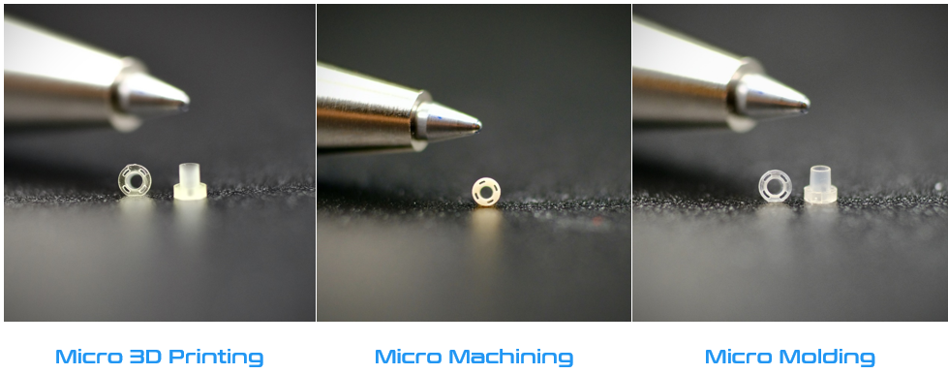

You Have Options!!….. for sampling and prototyping your Micro and Small precision plastic components.

Advancements in manufacturing processes have improved the speed and economics of sampling and prototyping. As a full service supplier, Mikrotech offers 3D printing, CNC machining, and Micro Injection molding for prototyping and production. Each option has its advantages and is dependent on where you are at in the development cycle and your ultimate product launch objectives. Careful consideration of form, fit, and function is the key to choosing the right process for your prototyping needs. Collaborate with a production processor to design your prototype parts to reflect production intent. Our engineering team can guide your technical team through the process to ensure that our components meet your expectations each step of the way.

**www.mikrotech.com**

**9900 58th Place, Suite #300,**

**Kenosha WI, 53144**

**Tel: 262.577.0231**

**Email: sales@mikrotech.com**

* Micro 3D Printing  
  Capable of achieveing dimensions as small as 10 microns. Biocompatible resins for medical needs available.
* Micro Machining   
  Offering best-in-class multi-axis CNC and Swiss-scew machining services. Ability to achieve tolerances down to .0002”. Resins include ABS,PEEK, PC, LCP, Stainless Steels, and more.
* Micro Molding  
  Capabilities include .003” wall thickness. Through holes as small as .0046”. Extensive processing knowledge in a variety of engineer grade resins.
* PROJECT MANAGEMENT  
  Design assistance to ensure manufacturability every step of the way!

YOU HAVE OPTIONS!

SERVICES AVAILABLE

Proof is in the Prototyping!